Task 15 : **VPC Creation Using NAT Gateway**

**VPC**: A VPC is a private, isolated section of a cloud provider's network, allowing users to launch resources in a virtual network.

1. Created a VPC

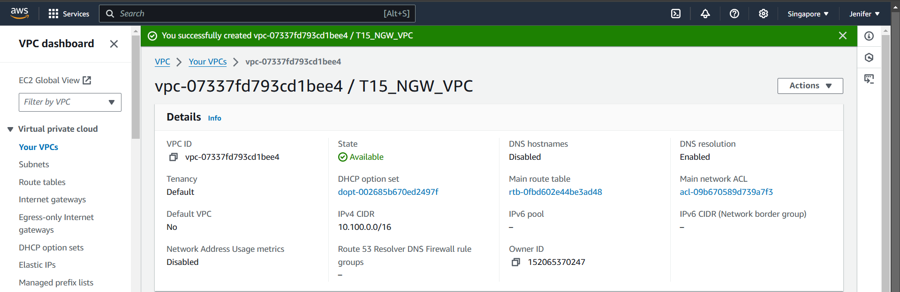

**Public Subnet**: Has direct access to the internet through an internet gateway. Instances in a public subnet can send and receive traffic from the internet.

**Private Subnet**: Does not have direct internet access; instances in a private subnet typically use a NAT gateway for outbound internet connectivity while remaining inaccessible from outside

1. Created Public & Private Subnets

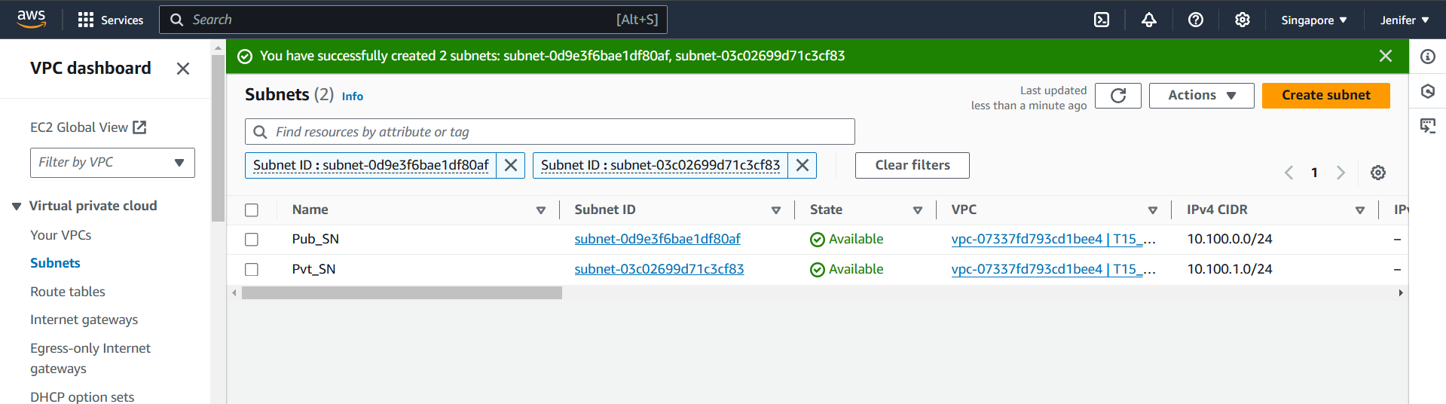

**Route Table:** A route table is a set of rules, called routes, used to determine where network traffic is directed within a VPC. Each subnet in a VPC is associated with a route table, which defines how traffic is routed (e.g., to an internet gateway for public subnets or a NAT gateway for private subnets). Route tables help control traffic flow and ensure it reaches the correct destination, whether within the VPC or externally.

1. Created Public & Private RTs

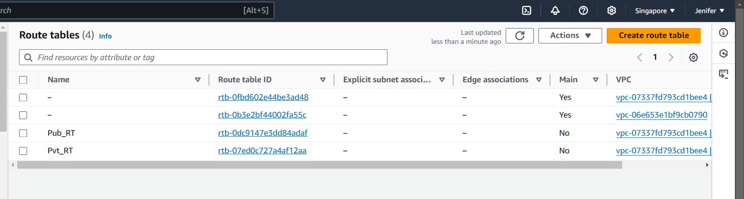

**Internet Gateway:** An Internet Gateway (IGW) is a component in a VPC that enables communication between instances in a public subnet and the internet. It provides a target in route tables for internet-bound traffic and allows instances with public IP addresses to send and receive traffic from the internet, making it essential for public-facing applications.

1. Created an Internet Gateway

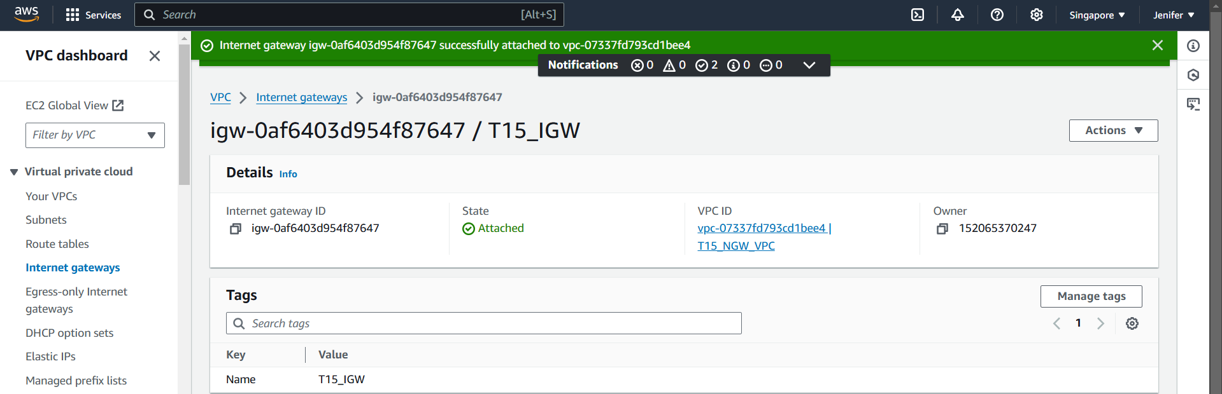

**NAT Gateway**: A NAT (Network Address Translation) Gateway is a cloud service that enables instances in a private subnet to connect to the internet or other external services while preventing incoming connections from the internet. NAT gateways allow secure outbound internet traffic by masking private IPs behind the gateway’s public IP, often used to download updates or communicate externally without exposing internal resources.

1. Created a NAT Gateway

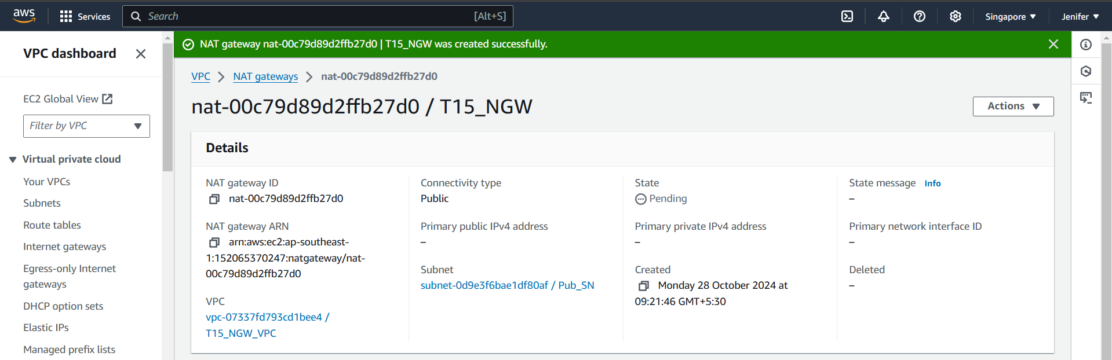

1. Launched two instances named Webserver & Appserver

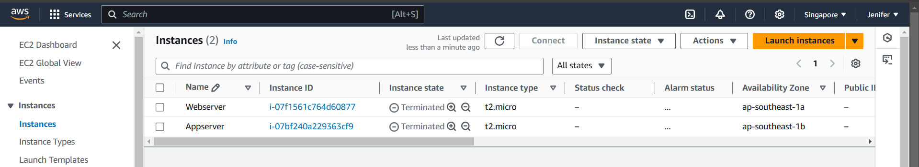

1. Jumping into the Private subnet’s Instance (Appserver) Using PEM key authentication

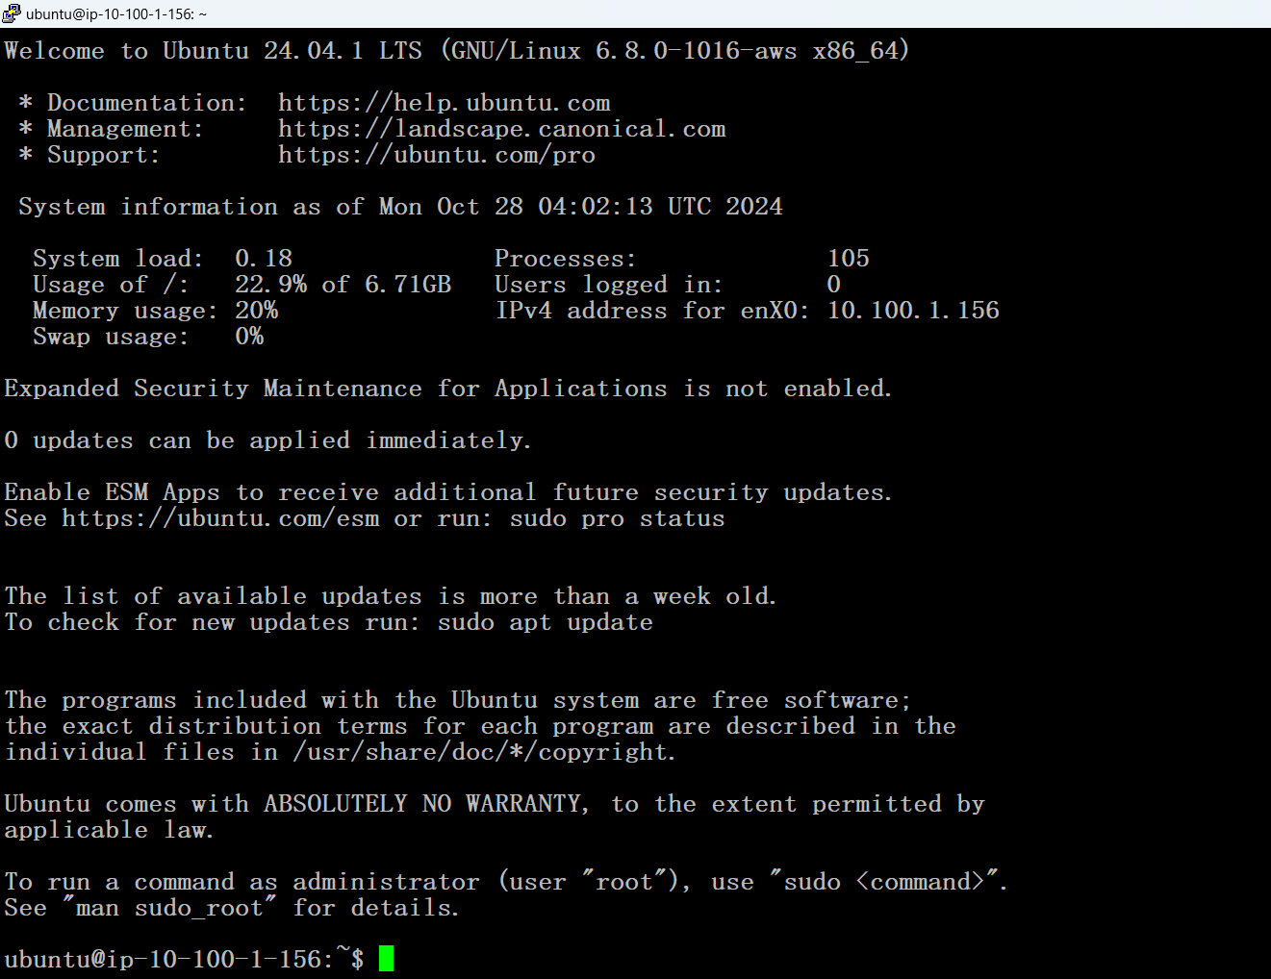

1. Installed Jenkins in the Appserver (Pvt_SN’s instance) using the internet via NAT gateway

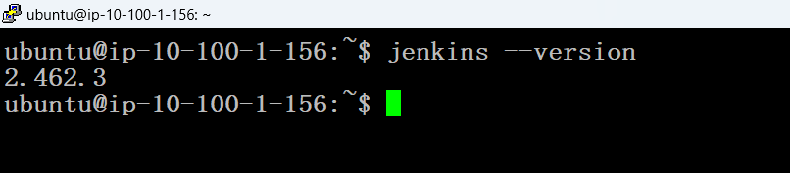

1. The App( Jenkins) which is in Private Subnet’s Instance is inaccesible from outside

